Pythagoras Lodge #358 F&AM

109 South Arnold Road
Panama City Beach, Florida 32413

Regular meetings are held on the 2nd and 4th Thursday of each month. Instruction & practice meetings are held each Tuesday at 6:30 PM


Worshipful Master
Richard (Rich) Allen Jr.
850-276-9463
rallen@zeltech.com

Senior Warden
Daniel D. Massoni
620-629-5872
dan.massoni@gmail.com

Junior Warden
Tony Thomaston
850-59774-0295
tonythomaston5761@gmail.com

Treasurer
Daniel Hinz
850-890-6277
djhinz@gmail.com

Secretary
R∴W∴ Archie Maynard, PDDGM
850-527-0930
archiemaynard@yahoo.com

Senior Deacon
Don Buchanan

Junior Deacon
Larry Carnley

Chaplain
Tim Ellis

Marshall
R∴W∴ Dean Resch, PDDGM

Senior Steward
Damien Gibson

Junior Steward
Nicholas Sams

Tyler
David Schwartz

Pythagoras Officers

Masonic Instruction and Lodge Officer Floor work will be conducted each Tuesday evening at 6:30 PM

Monday Nov 10th Practice for Acme MM Degree @ Callaway Lodge No. 369 7 PM
Monday Nov 10th York Rite Stated Meeting @ Acme Lodge No. 222
Tuesday Nov 11th FC Degree @ St. Andrews Lodge No. 212 Eat 6:30 PM
Tuesday Nov 11th MM Degree @ Acme Lodge No. 222 Eat 6:15 PM
Wednesday Nov 12th Masters & Wardens @ St. Andrews Lodge No. 212 7 PM
Thursday Nov 13th. Pythagoras Stated Meeting and Family night. Eat 6:30/Meet 7;30
Friday Nov 14th Scottish Rite/Exec. & KSA 6:30 PM/Stated 7:30 PM (Election of Officers)
Wednesday Nov 19th District School of Instruction @ St. Andrews Lodge No. 212 7 PM
Thursday Nov 20th FC Degree @ Callaway Lodge No. 369 Eat 6 PM
Friday Nov 21st Shaddai Shrine Stated Meeting Social 6 PM Meeting 7 PM
Saturday Nov 22nd Lodge Officers Training Module @ St. Andrews Lodge No. 212 Eat 8:30 AM
Monday Nov 24th York Rite Stated Meeting @ Acme Lodge No. 222
Wednesday Dec 3rd Zone/District (Open Books) School of Instruction @ Scottish Rite 7-9 PM
Friday Dec 5th First Friday Dinner (Public Welcome) @ Shaddai Shrine Social 6 PM Dinner 7 PM
Monday Dec 8th York Rite Stated Meeting @ Acme Lodge No. 222
Wednesday Dec 10th Masters & Wardens @ St. Andrews Lodge No. 212 7 PM
Friday Dec 12th Scottish Rite/Exec. & KSA 6:30 PM/Stated 7:30 PM (Installation of Officers)
Wednesday Dec 17th District School of Instruction @ St. Andrews Lodge No. 212 7 PM
Friday Dec 19th Shaddai Shrine Stated Meeting Social 6 PM Meeting 7 PM
Monday Dec 22nd York Rite Stated Meeting @ Acme Lodge No. 222
Monday Dec 29th Family Night Parker & Bay Lodges
Monday Dec 29th Installation of Officers @ Pythagoras Lodge No. 358

SATUDAY JANUARY 10TH G. RODMAN PORTER DAY
APPALACHICOLA LODGE NO. 76

ST. ANDREWS LODGE HAS CHALLENGED ALL LODGES IN THE 6TH MASONIC District TO A MEMBERSHIP ATTENDENCE AT THIS EVENT…AGAIN

If you have any important questions on Upcoming work, contact your W∴M∴ or our District Instructor.

R∴H∴ Mark C. Dragon
(850) 832-3576 Cell (850) 763-5355 Fax

UPCOMING WORK November, 2014

FELLOWSHIP

WELCOME TO THE
PYTHAGORAS WEB SITE

It is now available at www.pythagoras358.org

If you go to that site and subscribe you will get an e-mail message any time something new is added to the site. The Trestleboard will also be there. Also please continue to send your e-mail addresses to R∴W∴ Archie so we can keep sending the Trestleboard via e-mail. The more we can send by e-mail the less we will spend on printing and postage.

NOTE: Pythagoras will be Dark on November 27th due to Thanksgiving.

The First Thursday of each Month is Family night. Please bring a covered dish to complement the meal. Vegetables breads and deserts are always a welcome addition to the main course.

Family night hasn’t been well attended by spouses or significant others lately, so if your wife or girlfriend says you never take her out anywhere, here is your chance!

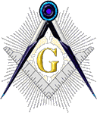

Pythagoras Lodge #358 F. & A. M.
PO Box 7282
Panama City Beach, FL 32413
PRESORTEDSTANDARD
U.S. POSTAGE

PAID
PERMIT 68
PANAMA CITY, FL

Hello Brethren,

Perpetual Membership.

It is a great way to avoid having to pay annual dues each year and provide a perpetual income for our Lodge.

Remember, there are several ways to pay for your perpetual membership ($700.00), Emeritus status, or just see me.

An installment plan is also available for you to consider.

Fraternally,
R∴W∴ Archie Maynard, PDDGM Lodge Secretary

My Brothers,

On November 1st Tupelo Lodge No. 289 F & AM will hosted their Master Mason outdoor Degree and Fish Fry. This year was a huge success. Our Lodge had seven people there. The Past Masters Unit of the Shrine did a great job with the degree. The fish fry was fantastic as well. .A big thank you to the brothers that came out for the event! The degree was something to watch. There was even a Brother that drone from Alabama for the degree.

The proceeds from our Butt cooking this year have benefited the Demolay, Rainbow Girls, Arnold High School Special Olympics, Arnolds Autism program, the Mr. Surfs Bible outreach program for youth groups, and the Autism Program at Breakfast Point. Below are a few pictures of some of the recipients.

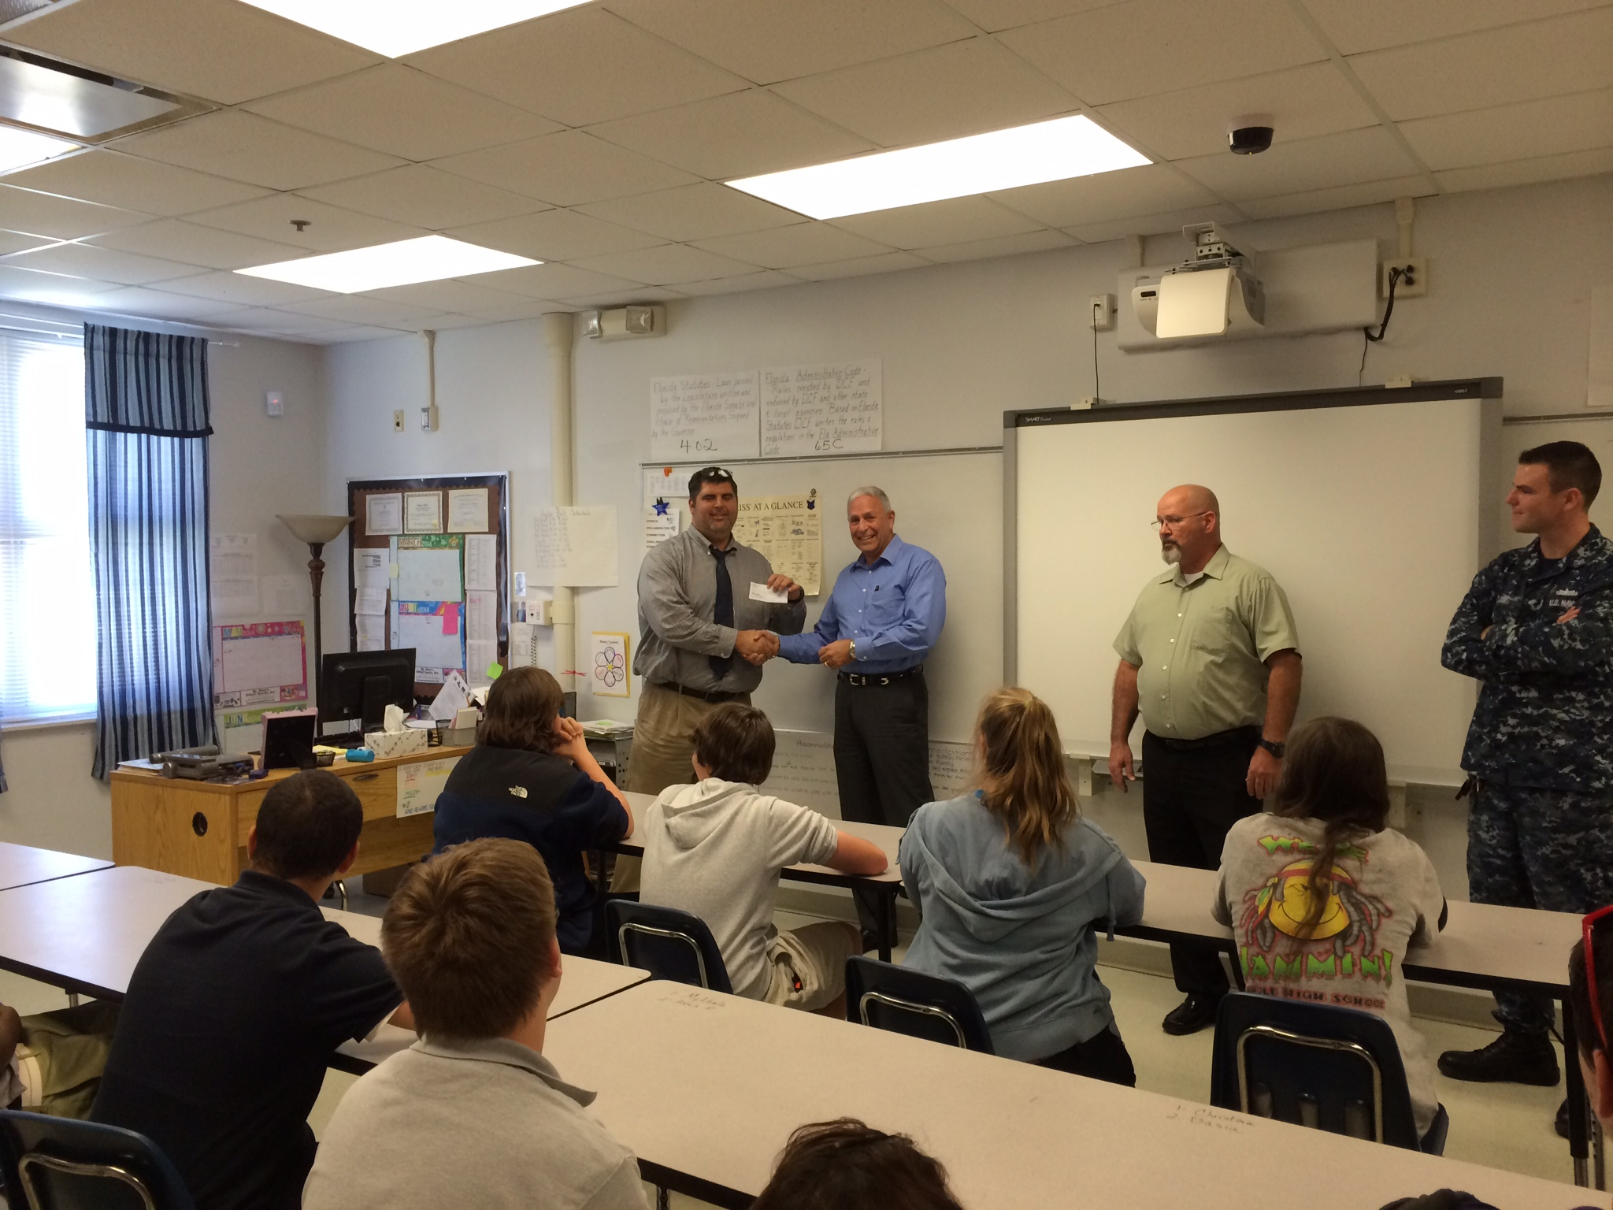

Arnold Principal accepting a check for Special Olympics April

FROM THE SECRETARY

FROM THE EAST
Quotes
FROM THE EAST CONT.

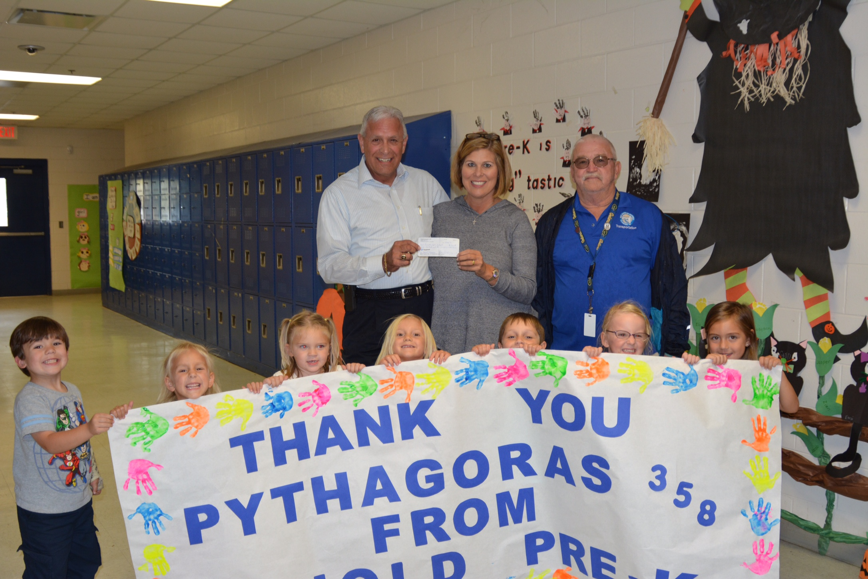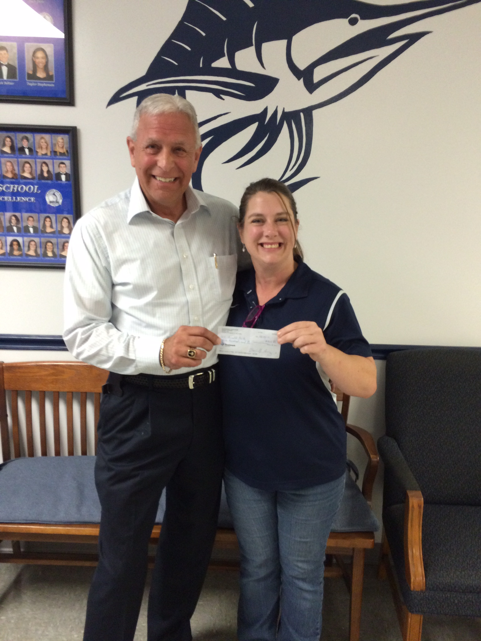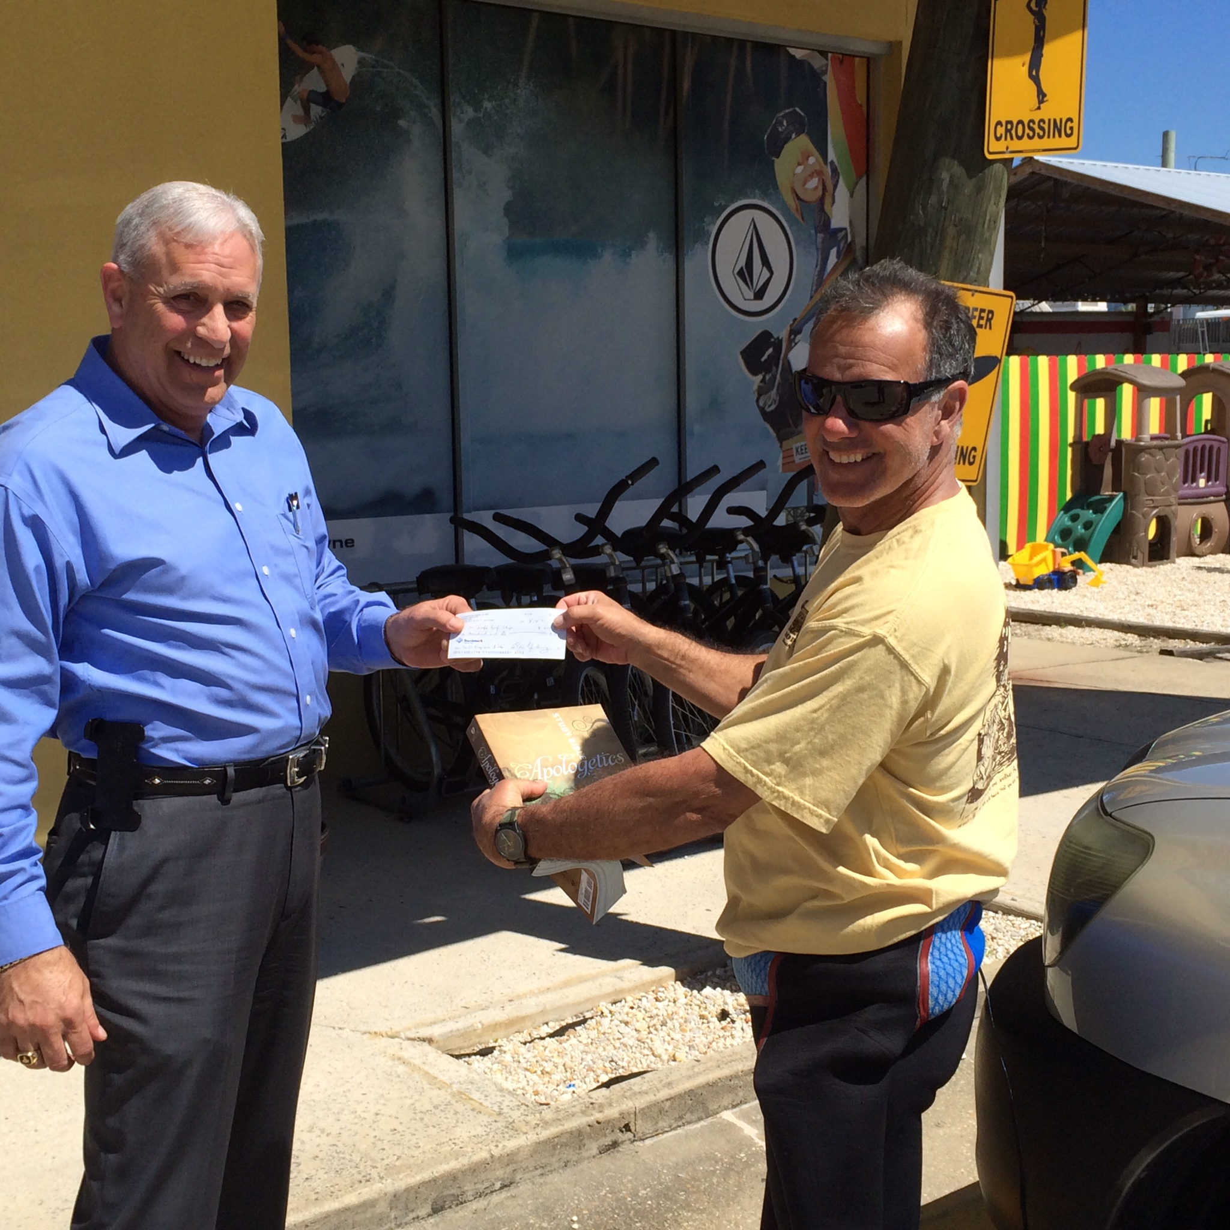

Arnold HS Autism October Special Olympics October Mr. Surfs Bible Program

We have done great things for our community this past year so give yourself a big pat on the back.

Some people live an entire lifetime and wonder if they have ever made a difference in the world, but our military doesn’t have that problem

Happy Veterans Day!!

