Pythagoras Lodge #358 F&AM

109 South Arnold Road
Panama City Beach, Florida 32413

Regular meetings are held on the 2nd and 4th Thursday of each month. Instruction & practice meetings are held each Tuesday at 6:30 PM


Worshipful Master
Bro. Chris Meissner
850-426-0858
Csmeissner87@gmail.com

Senior Warden
Don Buchanan
850-624-6336
Bdon520@knology.net

Junior Warden
Bro. Daniel Hinz
850-890-6277
djhinz@gmail.com

Treasurer
W∴ Daniel D. Massoni
620-629-5872
dan.massoni@gmail.com

Secretary
R∴W∴ Archie Maynard, PDDGM
850-527-0930
archiemaynard@yahoo.com

Senior Deacon
R∴H∴ Rick Hawks

Junior Deacon
Bro. Dave McKey

Chaplain
Bro. Larry Carnley

Marshall
W∴ Rich Allen Jr.

Senior Steward
Bro. Patrick Delay

Junior Steward
Bro. David Schwartz

Tyler
R∴W∴ Dean Resch

Pythagoras Officers

Masonic Instruction and Lodge Officer Floor work will be conducted each Tuesday evening at 6:30 PM

Thurs June 9th Pythagoras Stated Meeting Family Night Dinner 6:30, Meeting 7pm
Saturday June 11th Scottish Rite BBQ at Temple
Tuesday June 14th Flag Day
Tuesday June 14th Pythagoras Study night 6:30pm
Thursday June 16th Big River Scottish Rite Club
Friday June 17th Shaddai Stated Meeting 7pm
Sunday June 19st Fathers Day. Take the day off!
Tuesday June 21nd Pythagoras Study night 6:30pm
Thursday June 23th Pythagoras Stated Meeting the Lodge will be DARK
Friday June 24th Scottish Rite stated meeting. Dinner 6:30pm Mtg 7:30pm
Monday June 27th York Rite Meeting. Acme Lodge, dinner 6:30pm Meeting 7:00pm
Tuesday June 28th Pythagoras Study night 6:30pm
Thursday June 30th Family night at St Andrews and Tupelo Lodges
Friday July 1st, Shaddai Dinner Meeting 6:00pm
Monday July 4th, Independence Day
Tuesday July 5th Pythagoras Study night 6:30pm
Monday July 11th Scottish Rite KCCH Meeting 7:00pm
Tuesday July 12th Pythagoras Study night 6:30pm
Wednesday July 13th masters & Wardens, St Andrews Lodge 7:00pm
Thurs July 14th Pythagoras Stated Meeting Family Night Dinner 6:30, Meeting 7pm
Friday July 15th Shaddai Stated Meeting 7pm
Tuesday July 19th Pythagoras Study night 6:30pm
Thursday July 21st Big River Scottish Rite Club
Friday July 22nd Scottish Rite stated meeting. Dinner 6:30 Mtg 7:30pm (Casual Dress)
Monday July 25th York Rite Meeting. Acme Lodge, dinner 6:30pm Meeting 7:00pm
Tuesday July 26th Pythagoras Study night 6:30pm
Thursday July 28th Pythagoras Stated Meeting the Lodge will be DARK

We will have Brother Kraig Pakulski passing to FC, but the date is TDB for now.

If you have any important questions on Upcoming work, contact your W∴M∴ or our District Instructor.
R∴H∴ Keith Hartless
hartkeit@comcast.net

UPCOMING WORK June / July, 2016

FELLOWSHIP

WELCOME TO THE
PYTHAGORAS WEB SITE

It is now available at www.pythagoras358.org/

If you go to that site and subscribe you will get an e-mail message any time something new is added to the site. The Trestleboard will also be there. Also please continue to send your e-mail addresses to R∴W∴ Archie or W∴ Rich Allen rallen@zeltech.com so we can keep sending the Trestle Board via e-mail. The more we can send by e-mail the less we will spend on printing and postage.

Each Tuesday morning from 8am ish to about 10am ish, the Brethren and Friends gather for coffee and fellowship. There is really no set time, show up at your leisure. Come on out to the lodge to meet and greet your friends and Brothers. This is not restricted to Masons only. Bring your neighbor or a friend. We hope to rekindle the interest of our past members and perhaps encourage new membership.

The First Thursday of each Month is Family night. Please bring a covered dish to complement the meal. Vegetables breads and deserts are always a welcome addition to the main course.

Family night hasn’t been well attended by spouses or significant others lately, so if your wife or girlfriend says you never take her out anywhere, here is your chance!

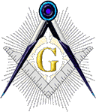

Pythagoras Lodge #358 F. & A. M.
PO Box 7282
Panama City Beach, FL 32413
PRESORTEDSTANDARD
U.S. POSTAGE

PAID
PERMIT 68
PANAMA CITY, FL
Hello Brethren,

Perpetual Membership.

It is a great way to avoid having to pay annual dues each year and provide a perpetual income for our Lodge.

Remember, there are several ways to pay for your perpetual membership ($700.00), Emeritus status, or just see me.

An installment plan is also available for you to consider.

Fraternally,
R∴W∴ Archie Maynard, PDDGM Lodge Secretary

My Brothers,

WE GOT IT!!! A picture is worth a thousand words!

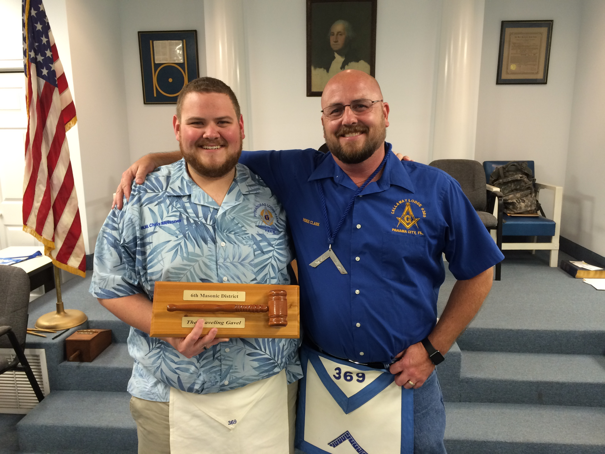
Pythagoras #358 captured the 6th Masonic District Traveling Gavel from Callaway #369 who has had possession of it for the last three years.

Thanks to all that assisted in our Lodge taking the Traveling Gavel from Callaway. I’m sure they’ll be at our Lodge soon to get it back.

Congratulations to Brother Kraig Pakulski in turning in his EA catechism. We will send out the date for his FC as soon as we have one.

Background checks for Brothers working the Child ID program are required every 4 years. To update your check go to http://grandlodgefl.com/docs/GLF_ChildID/Background%20Waiver%20Child%20ID%20Program.pdf for the form, instructions are contained.

Stop on by the lodge on Tuesday mornings around 9ish AM as the coffee club is going full swing.

Hope everyone has a great month, take care and be safe,

Chris Meissner, Worshipful Master

FROM THE SECRETARY

FROM THE EAST
Quotes
Trestle Additions/Information

What we have done for ourselves alone dies with us; what we have done for others and the world remains, and is immortal.”
Albert Pike

A Lodge is like a church in that some members take its teachings more seriously than others. The hope, of course, is that all will progress in their understanding and practice of the teachings. A charge in the Master's Degree that we use states that: "There are four classes of men in the world: First, those that are Masons neither in name or by nature; second, those who are Masons in name only (unfortunately); third, those who are Masons by nature only; and, lastly, those who are Masons in name and by nature, and this class are God's noblemen." It goes on to say: "If I cannot be numbered among them (Masons in name and by nature), then I would rather be a Mason by nature, which is in my heart, than a Mason in name only."
Like you, I sometimes struggle with the fact that we have a lot of Masons in name only, and that the obligation is taken lightly by many. However, in my many years in Masonry I have come to realize that none of us are close to perfect and that we are all on the same journey, some further along than others, and that the best I can do is to continue my journey and offer assistance to any Brother that can use my help. When I served in the East our Lodge adopted a motto: "Follow the Light, Share the Light." If we all work hard to do that I think Masonry will be fine. Hang in there Brother, your Light may be the Light someone is following.

W∴ Kenneth Pipkin
Ocean Lodge 214
Georgia

